Santhanakrishnan Ramani

SID: 105720585

**Assignment 1**

***Task 1:***

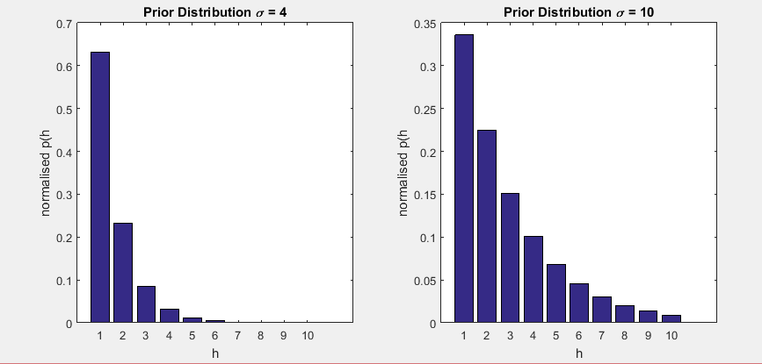

***Task 2:***



***Task 3:***



***Task 4:***



***Task 5:***

 





**How Posterior varies when new examples are added:**

* As the number of examples increases the posterior value tends to decrease.

**Reason:**

* Posterior is directly proportional to likelihood times the prior.
* Prior value doesn’t depend on the no. of examples
* Which implies Posterior is directly proportional to likelihood
* Likelihood decreases as the no. of examples increases as
  + P (X|h) = 1/ (|h|^n) if for all i, x (i) is an element of h, and
  + The chance that all the examples in X are present in the given hypothesis becomes low.
* So the Posterior value decreases as the no. of examples increases.